
FUTURE PROJECTIONS LIMITED
UNIT 2, THE WINDSOR CENTRE
ADVANCE RD, off WINDSOR GROVE,
WEST NORWOOD, LONDON SE27 9NT
TEL: (+44) 020 87667100
www.fproj.com
FAX: (+44) 020 87667090
MOB: (+44) 07710 409 328

EMAIL: peter@fproj.com skype peter.hall.fproj www.fproj.com

To; Ben Prickett
Haverhill Arts Centre
Technical Assistant
Haverhill Art Centre,
High St,
Haverhill
CB9 8AR
ben.prickett@haverhillartscentre.co.uk Spike

From; Peter Hall
Date; 9 July 2019
Subject; D cinema costings
BY EMAIL AND POST

Dear Ben

Thanks for your email – pricing as before for upgrading the servers, otherwise I thought I would send you generic costings for a variety of options given the age of the gear.

We hear a lot of other integrators spreading panic stories about older DCI gear and whilst we need to break even here we also feel there is an element of panic in some of the sales-pitches being put forward. Your Barco is getting on however it is one of the most solid DCI machines ever made and Odeon alone have hundreds still running. It may die tomorrow however equally it could give another 5 years life, but I do agree that some parts are not available from Barco (however at this stage all parts are available off our own shelves). The server is sadly another matter and is unlikely to run much beyond 10 years – if you have had 12 then well done ! The CP is a good processor however current models are ¼ of the price and do all that you need to for D cinema.

We are keen to be flexible and have attached four options for upgrade. Whilst we would not usually resell a unit of it’s age, we are prepared to further offer a trade in of your existing kit of at least £2000 on all but the rental option, and possible on the rental contingent on a term exceeding 3 months – let us know if this is of interest.

I have tiered the options, from the highest (laser projector, new everything, new network an touch controller) to a basic second hand option and a further rental option. Option 1 includes a better sound processor which also offers remote control and a touch screen interface for DCI gear, and all options include a new Dolby or similar processor and a new alternative content processor.

There are some further options which we can offer, for instance a life extension on the CP2000 as well as either a new or rental server and ACS – let us know if these are of interest.

I hope that this is of interest – we aim to be flexible and to produce innovative solutions for our clients’ individual needs and would be happy to meet up and show you around some of our past jobs if this is of use to you.

Kind regards

Peter Hall

PROPOSAL PREPARED FOR UPGRADE / LONG TERM

PROPOSAL PREPARED FOR ROSES TEWEKESBURY 3
The Venue 4
Requirements / brief 4
Our proposals – Summary 4
What will you be able to do ? 4
Total cost of ownership / Finance 5
Costings - 6
Why Future Projections ? 10
Logistics and installation details 10
About us 14
Clients include 14
Peter Hall ABOUT FUTURE PROJECTIONS 18

The Venue
To recap our discussions re the venue

Throw :Long !
Screen width 8m so entry level
Screen height 3m ish
Projector location Good projection room, nasty stairs from memory
Removal works CP2000 tbc
ASDL required
Power Assume 32A 3P
Cooling and extract Assume none
Port windows
Top assume 35mm compatible
Bottom
Angle
Access
Doors

Requirements / brief
Upgrade or replacement for DFP Christie DP2000 . DOlby
Our proposals – Summary
Projector options

Xenon lamps – all machines except the L models and the DP2k6E – these use industry standard lamps, lasting approximately 2000 hours and costing around £500. Barco machines use modular lamphouses and we give training in changing these – a fairly simple job perhaps every six months or up to every two years

UHP lamps – the Barco DP2k6E uses 2 x UHP lamps. These are the ONLY UHP lamps which are designed and approved for DCI use, and are guaranteed to last 1500 hours @ around £750 so the cost of operation is slightly higher than the equivalent Xenon machine. On paper they are not as bright however we have found the opposite. They are good for cinema and remote operation where unskilled operators prevail as they can be changed by anyone and the machine has two so a backup is present

2P laser – smaller machines have the option of a 2 colour laser with a colourwheel to give the third gamut. Note that this is NOT the 6P laser which is found in larger machines, moreso a longer life option than xenon with a life claiming to be up to 30000 hours, or 15 xenon lamps. These units are new to the market and cost a lot more up front than xenon units however have far lower running costs. Note that in order to benefit from the claimed long life of the laser, an extended warranty is highly recommended. There is no performance or visual advantage over xenon or UHP so the choice is purely one of risk and capital vs operating costs.

6P laser – larger machines have the option of a 6 colour laser, and require extra cooling and present some subsequent safety issues. These are the brightest units on the market and exclusively Barco integrate these in the projector, with the power supply remote. Life is claimed to be up to 30000 hours, or 15 xenon lamps. These units are new to the market and cost a lot more up front than xenon units however have far lower running costs. Note that in order to benefit from the claimed long life of the laser, an extended warranty is highly recommended.

What will you be able to do ?
D cinema – screen 2D or 3D (with glasses and adaptor) DCI feature films and both encrypted and unencryptyed content#
E cinema – screen non DCI content off air, network or DVD, BDD or other formats#
Live – screen live events via satellite (required)
PA and music – interface and use system as a PA
Events and corporate – plug in a Mac or PC and run powerpoint or video direct from your PC

Total cost of ownership / Finance
We choose Barco projectors for their reliability, long life and lowest cost of running. Historically Barco projectors have the highest trade in value of any projector. Barco guarantee longer spare parts availability than any other manufacturer, and usually hold substantial spare parts well beyond this period. Projectors are designed out of steel, based on larger "rock and roll" machines - extract, cooling, light engines and power supplies are all based on larger machines designed for far heavier duty cycles. Reliability, running costs and resale all benefit.

We now offer finance options through Medialease Ltd. Medialease offer finance over flexible terms and can offer either tax-efficient rent-to-own or lease deals. Finance is offered by Medialease Limited and is at the discretion of the finance company and subject to credit approval.

Typical lease figures in this instance would be

Costings -
Please find attached costings for a D cinema set up, complete with DCI approved projector, server and infrastructure to allow you to screen any current Hollywood or world film, old or new. I think we discussed this however there are alternative options in E cinema, which is not DCI approved and therefore cannot show much content in advance of it'd DVD release, and these options are around ¼ of DCI gear cost - it us our understanding that this is not what you are looking for however do let me know if I am wrong.
Option 1
New LASER projector, new Datasat processor and automation, new Kramer scaler

PROPOSAL
OPTION 1 - REPLACEMENT PROJECTOR AND SERVER AND SOUND AND SCALER - NEW , LASER |  | Version
D CINEMA - HARDWARE
Standard cinema plinth, 1000 x 600 for 10SX (fits in 35mm space) | 1 | £1,125.00 | £1,125.00
VIDEO MONITORING
Mullti input monitor, 18" VGA, HDMI2, CV, CV | 1 | £149.99 | £149.99
Monitor wall bracket, double jointed, 1m reach | 1 | £103.99 | £103.99
D CINEMA PROJECTORS
ALL BARCO PROJECTORS COME WITH MOTORISED LENS, LAMP AND CLO INCLUDED
SP4K-12C ICP-D C LNS | 1 | £39,059.17 | £39,059.17
NETWORK
Wireless modem / hub Draytec full feature | 1 | £337.50 | £337.50
Laptop computer 15" wireless configured with software | 1 | £412.50 | £412.50
Network commissioning, cabling etc | 1 | £135.00 | £135.00
Webcam for remote assistance | 1 | £28.00 | £28.00
Long extension cable for webcam video | 1 | £52.50 | £52.50
C5A 24 way patch field | 1 | £155.00 | £155.00
Basic unmanaged switch | 1 | £129.99 | £129.99
C5 patch leads to hub | 1 | £1.08 | £1.08
ALTERNATIVE CONTENT PROCESSORS
Kramer VP444 12-in Analog and HDMI Presentation scaler/switcher | 1 | £1,071.53 | £1,071.53
SOUND
AUDIO PROCESSORS
Datasat / DTS |  | £0.00 | £0.00
DTS/Datasat AP25 channel full cinema processor with DIRAC includes TOUCH SCREEN AUTOMATION | 1 | £3,750.00 | £3,750.00
INSTALLATION. LOGISTICS and DELIVERY etc
Install incl delivery | 2 | £399.00 | £798.00
Install - standard engineer | 2 | £299.00 | £598.00
Travel, accommodation, PDs etc |  |  | £200.00
Workshop prebuild |  | ALWAYS INCLUDED
TOTAL |  |  | £48,107.23
VAT |  |  | £9,621.45
TOTAL INCLUDING VAT |  |  | £57,728.68

Option 2
New xenon projector, new Dolby processor, new Kramer scaler

PROPOSAL
OPTION 2 - REPLACEMENT PROJECTOR AND SERVER AND SOUND AND SCALER - NEW , XENON MACHINE |  | Version
D CINEMA - HARDWARE
Standard cinema plinth, 1000 x 600 for 10SX (fits in 35mm space) | 1 | £1,125.00 | £1,125.00
VIDEO MONITORING
Mullti input monitor, 18" VGA, HDMI2, CV, CV | 1 | £149.99 | £149.99
Monitor wall bracket, double jointed, 1m reach | 1 | £103.99 | £103.99
D CINEMA PROJECTORS
ALL BARCO PROJECTORS COME WITH MOTORISED LENS, LAMP AND CLO INCLUDED
DP2K-10S (INCL. ALCHEMY 1TB & 2.2kW LAMP & SPEC'D LENS) | 1 | £25,258.18 | £25,258.18
NETWORK
Wireless modem / hub Draytec full feature | 1 | £337.50 | £337.50
Laptop computer 15" wireless configured with software | 1 | £412.50 | £412.50
Network commissioning, cabling etc | 1 | £135.00 | £135.00
Webcam for remote assistance | 1 | £28.00 | £28.00
Long extension cable for webcam video | 1 | £52.50 | £52.50
C5A 24 way patch field | 1 | £155.00 | £155.00
Basic unmanaged switch | 1 | £129.99 | £129.99
C5 patch leads to hub | 1 | £1.08 | £1.08
ALTERNATIVE CONTENT PROCESSORS
Kramer VP444 12-in Analog and HDMI Presentation scaler/switcher | 1 | £1,071.53 | £1,071.53
SOUND
AUDIO PROCESSORS
CP750 | 1 | £2,500.00 | £2,500.00
INSTALLATION. LOGISTICS and DELIVERY etc
Install incl delivery | 1 | £399.00 | £399.00
Install - standard engineer | 2 | £299.00 | £598.00
Travel, accommodation, PDs etc |  |  | £200.00
Workshop prebuild |  | ALWAYS INCLUDED
TOTAL |  |  | £32,657.25
VAT |  |  | £6,531.45
TOTAL INCLUDING VAT |  |  | £39,188.70

Option 3
Reconditioned xenon projector, new Dolby processor, new Kramer scaler

PROPOSAL
OPTION 3 - REPLACEMENT PROJECTOR AND SERVER AND SOUND AND SCALER - ex hire projector |  | Version
D CINEMA - HARDWARE
Standard cinema plinth, 1000 x 600 for 10SX (fits in 35mm space) | 1 | £1,125.00 | £1,125.00
VIDEO MONITORING
Mullti input monitor, 18" VGA, HDMI2, CV, CV | 1 | £149.99 | £149.99
Monitor wall bracket, double jointed, 1m reach | 1 | £103.99 | £103.99
D CINEMA PROJECTORS
ALL BARCO PROJECTORS COME WITH MOTORISED LENS, LAMP AND CLO INCLUDED
Ex hire DP1500 or similar | 1 | £6,950.00 | £6,950.00
NEW Digicine server
Digicine Server without sleeve | 1 | £7,248.96 | £7,248.96
NETWORK
Wireless modem / hub Draytec full feature | 1 | £337.50 | £337.50
Laptop computer 15" wireless configured with software | 1 | £412.50 | £412.50
Network commissioning, cabling etc | 1 | £135.00 | £135.00
Webcam for remote assistance | 1 | £28.00 | £28.00
ALTERNATIVE CONTENT PROCESSORS
Kramer VP444 12-in Analog and HDMI Presentation scaler/switcher | 1 | £1,071.53 | £1,071.53
SOUND
AUDIO PROCESSORS
CP750 | 1 | £2,500.00 | £2,500.00
INSTALLATION. LOGISTICS and DELIVERY etc
Install incl delivery | 1 | £399.00 | £399.00
Install - standard engineer | 2 | £299.00 | £598.00
Travel, accommodation, PDs etc |  |  | £200.00
Workshop prebuild |  | ALWAYS INCLUDED
TOTAL |  |  | £21,259.46
VAT |  |  | £4,251.89
TOTAL INCLUDING VAT |  |  | £25,511.35

Option 4
Rental – long and short term pricing shown
PROPOSAL - OPTION 4 - RENTAL 3 MONTHS MINIMUM
 |  | Version
LONG TERM DCI RENTAL
D CINEMA - HARDWARE
Custom studio plinth for D cinema projectors (wired)
Standard lens height 1200mmm centre on a flat throw (as in 35mm)
2k D cinema projector - 3D ready, series 2 or Cinelink2 authorised
D cinema server - 2TB useful storage, USB ingest
Extract fan if required
Power supply from 16A C form (client supply)
Rack - footprint 1000mm x 600mm (door space 600mm) x 1400mm high (varies)
Wireless modem
Laptop or monitor for server and projector
WEEKLY - 12 week minimum hire | 12 | £299.00 | £3,588.00
WEELKY - 24 week minimum hire | 0 | £239.20 | £0.00
WEEKLY - 48 week minimum hire | 0 | £191.36 | £0.00
SOUND PROCESSOR and PATCH FIELD (for house PA)
WEEKLY - 12 week minimum hire | 12 | £22.18 | £266.16
WEELKY - 24 week minimum hire | 0 | £20.32 | £0.00
WEEKLY - 48 week minimum hire | 0 | £18.00 | £0.00
ACS SCALER for alternative content
WEEKLY - 12 week minimum hire | 12 | £22.18 | £266.16
WEELKY - 24 week minimum hire | 0 | £20.32 | £0.00
WEEKLY - 48 week minimum hire | 0 | £18.00 | £0.00
Long term DCI - install, flat rate |  |  | £1,000.00
Items outside hire - (purchase)
TOTAL |  |  | £5,120.32
VAT |  |  | £1,024.06
TOTAL INCLUDING VAT |  |  | £6,144.38

.

Why Future Projections ?

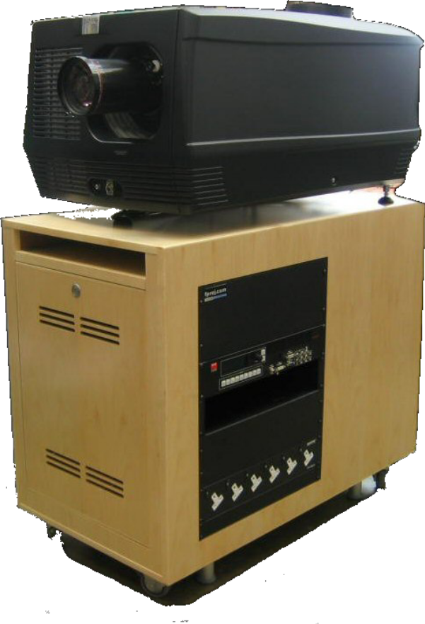
Service and Support
We would not be doing any installation justice without talking about support. Failures are rare and yet they do occasionally happen and we want to be prepared and enabled to assist. Your costing shows an option for year one service – this upgrades the factory “return to base” warranty, which runs from one year of installation and on some occasions two or three years from leaving the factory, to a “on site” warranty for larger items and a swap out or return to base warranty for smaller kit. We regard this service as vital as the factory warranty offered by all DCI suppliers is in our opinion not up to the needs of our clients to remain on screen. Do give us a call if you have concerns in this area.

Support is key to any installation. We don’t have call centres, diverted phones or service "tickets", nor will we divert you to a rota engineer who knows nothing about your site. We do have dedicated engineers, 24/7 mobiles and (subject to lines) full site connectivity at all times. We will have you talking to an engineer (or more likely an engineer talking to your projector) when others will have you searching for a code on the back of your server, in the dark with the audience waiting ! Most gear comes with a one year warranty however projector and server warranty is often longer, pending registration on the makers website. Manufacturer support is available too, from Barco's dedicated UK D cinema folk based in Reading, so no, you don’t need to speak Japanese nor wait till the Canadians wake up to answer a query !

Logistics and installation details
Key to our works are multi skilled engineers, in our opinion the best in the business. Whilst other suppliers may be larger, their skill base is more spread out and it is likely that an engineer calling would have sound OR picture OR network skills. Our guys are multi skilled and indeed we are the ONLY supplier in the UK to do both the lighting rig and satellite in-house.

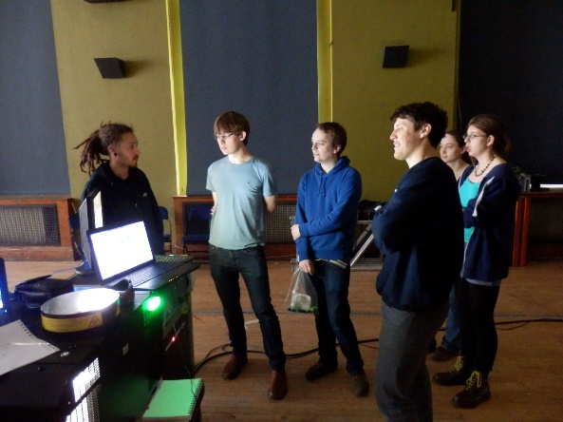
We will work with you to produce a detailed programme of delivery , installation and training. We regard this as critical and will negotiate and list critical and non critical dates for areas such as the following
- Deliveries, ensuring that the site conditions are appropriate
- Appropriate works and construction details from third parties, eg projection room clean and 230VAC on by x date
- Allow sufficient time within our own programme for both works and contingencies

Our background takes in 25 years of project management and building so we are both aware and sympathetic of last minute issues and will and do endeavour to work with these “expected” surprises. We understand that fit out schedules are often tight and we will work with you on this, adding extra last minute resources as required.
Projector delivery is currently quoted at up to four weeks depending on lenses, however we have stocks reserved for this time.

We have allowed within our pricing for one site visit in order to coordinate the installation and third party trades. We anticipate installation taking place in one or two continuous runs, during which times we anticipate spending long days on site in order to complete our installation in a timely and efficient fashion.

Operator training is anticipated to take place on site and should take half a day. Note that whist we offer detailed training in the specific equipment being installed, sometimes it is often not appropriate to train a non technical person “from the ground up” in the time allowed and therefore we would expect the technician being trained to have some relevant experience.

We believe that operator training is VITAL and propose the following
- During phase 1 or two of the installation, we will give initial training on DCP and operation to the key operator or two.
- Following this, we expect the operators to spend a couple of weeks “shaking down” the system. Experience has shown that failures, and more likely training issues, flag themselves in the first couple of weeks and we feel it is vital to have this time without the pressure of audiences
- We would then return and complete detailed and more advanced training for these folk, as well as a full basic training course for other operators
- During this time we would maintain on-line support and loan you some content for trialling

Items in blue are optional and have not been included in the bottom line.

All items come with both a manufacturer and our own warranty, covering them against part failure and defective workmanship. This is typically one year however some projector manufacturers extend one or both elements to two years.

On completion of the works and upon receipt of the final payment we will issue a full design manual, consisting of whatever manufacturers information we are in receipt of as well as “as built” technical drawings etc. Depending on content, this will usually be a ring bound folder and copies will be issued to yourselves. Preliminary manuals will also be made available for familiarisation during installation.

Our scope of works in this instance includes;

- Full and detailed specification documentation for third party trades
- CAD drawings etc as required
- Project management
- Builders work associated with xxxxxxxxxxxxx
- Projection and sound equipment as listed
- Full drawing and manual package on completion

Third party or client works required includes;
- Mains electrical works and supplies
- HVAC to our specification (generally projection spaces need to remain below 19 degrees Celsius with all gear running) - see notes, this may not be required
- Builders work associated with installation
- Screen and screen frame
- First fit electrical containment
- Second fit electrical cabling in theatre

Terms, finance and the small print
The pricing contained here is valid for a period of 30 days from the date of writing. Our standard terms of payment are;
With order 30%
On delivery 60%
30 days following completion 10%
We can usually offer public bodies full credit based strictly on 30 day terms.

Consultancy 50% with order
After initial presentation 50%

Do let us know if there is a problem with this as we do our best to be flexible.

We hold the following insurance;
Public liability - £5000000,
Product liability £10000000
Insurance liability for all equipment passes to the client on delivery.

Ease of operation and Automation
We provide free of charge training to all of our clients, either on site or in our offices. We’re also available for ongoing training for new staff and sites. Our system interfaces are standardised and very intuitive to operate. A series of password controlled levels are available to complement your management structure Automation systems for D cinema offer far more advantages than could initially be thought. Good skills are required to programme and "build" the film on receipt, however this can be done anytime whereas the skill required to show a film is as simple as setting a timer or pressing a button. Given a basic interface with your house lights, a simple automation system could self-run a full days or even a week worth of shows without manual intervention. More advanced systems can control anything from signage to curtains to theatre doors. There is no substitute for a good technician however adding a little control technology not only takes the mundane tasks of projection away from the operator (waiting 2 hours to turn the lights on at the end of the show is a thankless task !), freeing them up for other duties or to monitor the system either locally or remotely. Low yielding shows, which wouldn’t in the past have justified a projectionist and a print delivery, may suddenly become not only viable but profitable. Typically our clients will add extra screening dates or session times to take advantage of this.

UPS and Connectivity
We STRONGLY recommend the installation of a uninterruptable power supply for the projector and server electronics. This benefits at least half of our venues and minimises the chances of power fluctuations affecting or damaging hardware

We believe in total connectivity for D cinema - not only off site support but ease of local operation is greatly enhanced by the installation of internet or ASDL connectivity as well as local wireless. Our costings usually allow for a wireless network and netbook as standard. We have included the projector and server side of this in our costing, and strongly recommend the installation of a suitable network or ASDL line to allow for real world connectivity and support. This needs to be either a stand alone ASDL line or a wired network point where we can gain full internet access without altering our PC settings (we remote into this via Teamviewer). Let us know if we can provide more details.

HFR and Storage
Servers have either 2TB or 4T B capacity, with more available as an option. All options include AT NO EXTRA COST HFR software and compatibility.

Location options
Projectors are there to be used, not to be looked at or take up space where customers could otherwise sit ! We offer a wide variety of custom options including
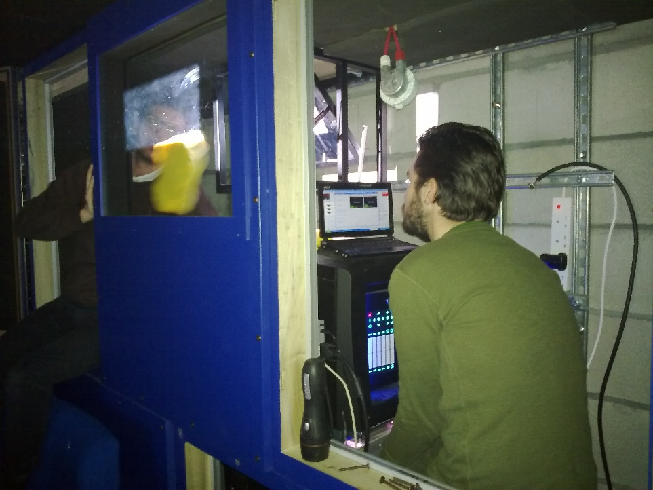
- Bespoke projection room – ideal, the easiest and we have kits designed to fit directly in place of 35mm gear
- Recessed or reduced projection room – suitable where space is limited or the room needs to function as for instance a tech room or theatre control room. Options are suspending, winching or integrating as part of the room fit out
- Rear wall vertical – *Barco SX and C range only* - looking like a projection room the most convenient from a service and upgrade point of view, our custom rear wall mounts can be as shallow as 500mm and can be either recessed into the rear wall or into the seating area in the space of two seats
- Suspended – with or without hush kits and hoists.
Call or check the drawings for more details

Integration

We know about D cinema, however we also know LOTS about cinemas – 30 year old curtain controllers, obscure sound processors, unusual booth layouts. We’ve worked with the best and the worst and have yet to encounter a situation into which we couldn’t deliver a full solution. We can if required arrange windows, ventilation and power or we are happy to work with your own suppliers on this.

Automation

Servers come complete with timer and programming functions, allowing the screen to be pre programmed either daily or weekly. Once programmed, the server (and any required interfaces) can control the theatre’s lights, sound, curtains, masking – even the theatre doors ! – and left unattended to run the day’s or week’s shows. This level of automation has led a number of our clients to consider adding additional smaller screening rooms given the near zero cost of operating these screens

Alternative content
D cinema isn’t just about replacing film with digits – indeed some of the capabilities have yet to be explored. Potential applications include
- live events – opera, sports, music
- private hire – content off PC, DVD or another source

- corporate events
- video conferencing
- combined recorded image / live events
- satellite relay
We offer solutions suitable for our clients needs – from the ability to plug a simple laptop or DVD in to a fully commissioned video edit suite.


Packages
All our packages are customised to suit the venue and operator’s requirements. Our standard building block includes a customised projector stand . Install can be as simple as plugging in the mains, network and sound and pointing the projector at the screen.


You’re in good company
Have a look at who we’ve worked with on D cinema – major film companies, cinema exhibitors, specialist theatre venues, retailers – talk to us, or more relevantly, let us arrange a visit to one of our clients – they are our best reference.

About us
From it’s roots in building New Zealand’s first art-house cinemas through to turnkey installations for some of the UK’ and Hollywood’s major players, Future Projections has been servicing the Audio Visual and Cinema needs of its customers for more than 25 years now. We continue to service the needs of its customers including hotels, motion picture studios, cinemas, screening rooms, Universities, event organisers and schools. We are unique in our passion for quality results and venue / technical design, be the source Digital, film, AV or high definition.

We specialise in high end or more challenging film, sound and Digital projection works and are exclusive UK authorised agents for Lucasfilm’s THX cinema programme. We have a proven track record in specialist venue, small multiplex and screening room / Digital projection venues and pride ourselves in offering comprehensive and attentive service that may not be possible from a larger organisation. In recent years we have developed a special interest in projects that are considered “too hard” – we have completed the largest, the smallest, the highest tech and some of the most curious and challenging moving image related designs and both permanent and temporary installations in the UK.

We work closely with architects and designers on the technical aspects of professional and private screening rooms and moving-image related aspects of alternative content venues. Our services range from design and consulting to full line equipment sales, project management, consolidation and coordination, installation and customer support for both new construction and renovations.

In the past years, we have realigned our organisation substantially to best serve the demands of a Digitised exhibition landscape. As well as a major recruitment initiative, we have invested heavily in networking skills and equipment, specialised test equipment and a number of custom physical and virtual tools to best serve the Digital cinema market. Each engineer is equipped to remotely control and diagnose any first level problems via his or her own “virtual NOC” (network operations centre), wherever they may be.

We don’t have third party call centres, fault reporting procedures, extensive paperwork or unskilled folk asking silly questions - we support you by a direct line to a qualified and skilled engineer.

We do have a team of qualified, dedicated employees, and a 24 hour support mechanism with technicians on call 364 days a year. We realize that our employees are our number one resource. That is why all of employees continue to be trained and certified in all areas of A/V and cinema related technologies on an ongoing basis and can handle any project, large or small.

We maintain;
- The highest engineer : installation ratio in the industry
- 100% factory trained engineering staff – nobody else can offer this
- Direct support relationships with all the manufacturers we represent
- A full set of test equipment for all engineers including exclusive use of the THX D2 acoustic system
- Comprehensive spare parts in our London workshop
- A direct line of communication to a site specific engineer
We believe that no other UK supplier can match all of the above offer a service to equal ours.

Clients include

Antony Reynolds Gallery
BAFTA
BARCO
Birkbeck College
The Charlotte St Hotel Screening Room
Chelsea Cinema
City Screen
Cornerhouse Manchester
Cornwall Film Festival
The Courthouse Hotel
Curzon Soho
Curzon HMV Wimbledon
Curzon Mayfair
Everyman Cinema and Media
Elgiva Theatre Chesham
Empire Leicester Square
Empire Cinemas UK wide
The Forbury Hotel
The Gardiner Arts Centre Brighton
Hammersmith Apollo
Hayward Gallery
The Haymarket Hotel
The Hospital (Screening room)
Holland Park (private screening room)
Irish Film Centre
Islington (private screening room)
BFI IMAX Theatre
Kensington Palace Gardens (private screening room)
Liverpool Biennial Festival
Lisson Gallery
Malta – Embassy Film Centre
Mayfair Radission Hotel
Metrocolour
Mr Youngs Screening Room
Nordern Farm Arts Centre
OASIS Media Dubai
Odeon Cinemas
Paramount UK
Planet Hollywood The Rex
Really Useful Group
Roses Theatre
Saffron Screen
Soho House
Soho Hotel
South Bank Centre – RFH, QEH
Tower Skegness
Swanage – Mowlem Theatre
Technicolor
Tyneside Cinema
UCI Ireland
University of East Anglia
University of Kent in Cantebury
University of East London
University of Plymouth
Ultimate Picture Palace Oxford
Warwick Student Cinema
Wareham Rex
Wembly Arena and Conference Centre
Windsor Arts Centre
Working Title Films (UK screening room)
Yamaha UK
York Student Cinema

TERMS AND CONDITIONS OF SALE / TRADE

Definitions
“Buyer” means the person who buys or agrees to buy the Goods from the Seller
“Terms” means the terms of sale as set out in this document and any special terms as agreed in writing by the Seller.
“Delivery Date” means the date specified by the Seller when the equipment and Goods are to be delivered and installed.
“Goods” means any projector and other related equipment and any other goods and equipment which the Buyer agrees to buy from the seller.
“Price” means the Price for the Goods and Work excluding carrier packing, insurance and VAT.
“Seller” means Future Projections Limited (Company Registration Number 3797445) whose registered office is situated at Unit 2 Windsor Centre Windsor Court SE279NT.
“Work” means the supply and installation and the servicing and repair of the Goods by the Seller.

COMPLETION
Practical completion shall be deemed to be no later than the first public or commercial screening (or the ability to do the same) by the client and all sums due on completion shall be payable on this date. Should such payment not be received, Future Projections retain ownership of the equipment and any use will incur rental charges until all payments are received. The purchaser agrees to pay both the account due on completion and the rental charges - payments will be allocated to rental accounts before capital accounts.

Terms Applicable
These Terms shall apply to all contracts for the sale of Goods and Work by the Seller to the Buyer to the exclusion of all other terms including any terms or conditions which the Buyer may purport to apply under any purchase order confirmation of order or similar document.
All orders for Goods or Work shall be deemed to be an offer by the Buyer to purchase Goods pursuant to these Terms.
Acceptance of delivery of the Goods shall be deemed conclusive evidence of the Buyer’s acceptance of these Terms.
Any variation to these Terms (including any special terms and conditions agreed between the parties) shall be inapplicable unless agreed in writing by the Seller.

The Price and Payment
The Price shall be the Seller’s quoted price for the Goods and Work as varied by agreement. The Price is exclusive of VAT, which shall be due at the rate ruling on the date of the Seller’s invoice.
Payment of the Price and VAT and shall be due within 30 days of the date of the invoice. Time for payment shall be of the essence.
Interest on overdue invoices shall accrue from the date when payment becomes due from day to day until the date of payment at a rate of 4% above HSBC’s base rate from time to time in force and shall accrue at such a rate after as well as before any judgment.
Unless otherwise agreed in writing between the Buyer and the Seller, payment for the Work shall be made in accordance with the following terms: -
Regular monthly stage payments shall be paid by the Buyer to the Seller the first such payment being due on the last day of the month following that in which the Goods are despatched or the Work is due to commence as appropriate.
Each such stage payment shall comprise the total value of Work executed and materials and Goods delivered to site for use thereon by the Seller prior to the date of such stage payment together with any other amounts then due, less only the aggregate amount of any previous stage payments and any agreed retention but subject to no other deductions whatsoever.
In respect of any materials or Goods which through no fault of the Seller are held in store, the value of the same together with any charges in respect of storage or rehandling shall be included in each monthly stage payment.
If the Buyer fails to make any payment when due the Seller may, at its option, and without prejudice to any other rights under the contract, suspend further Works until such Payment is made or terminate the contract. The Seller shall be entitled to charge in full with all interest where applicable interest on the outstanding balance of all overdue accounts from the time of default to time of payment (as well after as before judgment) calculated on an annual basis at a rate of 4% above the base lending rate of HSBC.
Notwithstanding anything contained herein the Seller shall be under no liability for loss and profits, revenue, contracts or business or any other form of consequential or indirect loss or damage of any nature whatsoever and however caused or arising.

Goods and Work
The quantity and description of the Goods and/or Work shall be as set out in the Seller’s quotation.

Warranties And Liability
The Seller warrants that the Goods and/or Work will at the time of delivery correspond to the description given by the Seller and, except where the Buyer is dealing as a consumer (as defined in the Unfair Contract Terms Act 1977 Section 12), all other warranties, conditions or terms relating to fitness for purpose, merchantability or condition of the Goods and/or Work implied by statute or common law or otherwise are excluded, including any loss or damage caused by or arising the incorrect operation of the Goods concerned, misuse, neglect, fire, flood, explosion howsoever caused and act of God and all consequential loss howsoever caused.

Advanced replacement goods
Our warranty, and those of most of our suppliers is “return to base” – goods need to be returned to us for evaluation and repair. In the event of a failure, we may have available “advanced replacement items”, to serve as either an interim loan item or a replacement unit pending warranty evaluation by the manufacturer. When we send these items, we treat these as a purchase – the client purchases the advance replacement item off us, we invoice for this and all carriage and once we receive the faulty goods back and verify the warranty claim we credit the cost of the goods. Clients need to agree these terms in writing prior to advance replacements being sent.

Delivery Of The Goods
Delivery of the Goods shall be made to the Buyer’s address on the Delivery Date, which is an estimate only. The Buyer shall make all arrangements necessary to take delivery of the Goods at the agreed location with the appropriate room / space for the Goods whenever they are tendered for delivery
Time for delivery is not of the essence of the contract
The Seller shall not be liable for any loss or damage whatever due to failure by the Seller to deliver the Goods (or any of them) promptly or at all.

Acceptance of the Goods and work
The Buyer shall be deemed to have accepted the Goods and/or Work 7 days after the date of the invoice relating to such Goods.
After acceptance the Buyer shall not be entitled to reject Goods and/or Work, which are not in accordance with the contract.

Title and Risk
The Goods shall be at the Buyer’s risk as from delivery.
In spite of delivery having been made title in the Goods shall not pass from the Seller until the Buyer shall have paid the Price plus VAT in full for such Goods.
Until title in the Goods passes to the Buyer in accordance with clause 8.2 the Buyer shall hold the Goods and each of them on a fiduciary basis as bailee for the Seller.
The Seller shall be entitled to recover the Price (plus VAT) notwithstanding that title in any of the Goods has not passed from the Seller.
Until such time as title in the Goods passes from the Seller the Buyer shall upon request deliver up the Goods. If the Buyer fails to do so the Seller may enter upon any premises owned occupied or controlled by the Buyer where the Goods are situation and repossess the Goods. On the making of such request the rights of the Buyer under clause 8.4 shall cease.
The Buyer shall not pledge or in any way charge by way of security for any indebtedness any of the Goods which are the property of the Seller. Without prejudice to the other rights of the Seller, if the Buyer does so all sums whatever owing by the Buyer to the Seller shall forthwith become due and payable.
The Buyer shall insure and keep insured the Goods to the full Price against “all risks” to the reasonable satisfaction of the Seller from the date of delivery until the date that property in the Goods passes from the Seller, and shall whenever requested by the Seller produce a copy of the policy of insurance. Without prejudice to the other rights of the Seller, if the Buyer fails to do so all sums whatever owing by the Buyer to the Seller shall forthwith become due and payable.
If requested by the Seller, the Buyer shall promptly deliver the prescribed particulars of this contract to the Registrar in accordance with the Companies Act 1985 Part XII as amended. Without prejudice to the other rights of the Seller, if the Buyer fails to do so all sums whatever owing by the Buyer to the Seller shall forthwith become due and payable.

Remedies of Buyer
Where the Buyer rejects any Goods and/or Work then the Buyer shall have no further rights whatever in respect of the supply to the Buyer of such Goods and/or Work or the failure by the Seller to supply Goods and/or Work which conform to the contract of sale.
Where the Buyer accepts or has been deemed to have accepted any Goods and/or Work then the Seller shall have no liability whatever to the Buyer in respect of those Goods.
The Seller shall not be liable to the Buyer for late delivery or short delivery of the Goods.
The Buyer shall inspect the Goods and/or Work on delivery and after installation and shall within 3 days after delivery or after installation notify the Seller of any alleged defect, shortage of quantity, damage or failure to comply with description or sample. If the Buyer shall fail to comply with these provisions the Goods and/or Work shall be conclusively presumed to be in accordance with the contract and free from any defect or damage which would be apparent on a reasonable examination of the Goods and/or Work, the Buyer shall be deemed to have accepted the Goods and/or Work.
If the Goods and/or Work are not in accordance with the contract for any reason the Buyer’s sole remedy shall be limited to the Seller making good any shortage by replacing such Goods and/or Work or, if the Seller shall elect, by refunding a proportionate part of the Price.
The Seller’s liability to the Buyer, whether for any breach of contract or otherwise, shall not in any event exceed the Price and the Seller shall be under no liability for any direct loss and/or expense or indirect loss and/or expense suffered by the Buyer or liability to third parties incurred by the Buyer.

GOVERNING LAW
This contract is subject to the Law of England and Wales.
The Seller warrants all Work carried out and covered by this estimate for a period of 6 months in respect of labour and workmanship. The Seller shall repair or replace defective Goods at his discretion. Any parts or Goods supplied and fitted by the Seller shall carry the warranty (if any) given by the manufacturer of that item. The Buyer shall during the relevant period ensure that the equipment is operated and maintained correctly

Cabling and other items
The Seller shall where reasonably possible conceal electrical cable within containment provided by othersm or otherwise as agreed. Price does not include the lifting and replacement of floorboards for the purpose of concealing cable.
Cables affixed to walls ceilings and doors shall be affixed to the surface thereof and the quotation or estimate or Price does not include the costs of concealing such cable.
The Buyer shall give the Seller access to its premises of not less than 8.5 clear hours per day between the hours of 7.00 am and 5.00 pm Monday to Saturday for the purpose of carrying out any act and the services and Work under the terms of this agreement.
The Buyer shall provide without charge to the Seller adequate facilities for the storage of materials equipment and tools during the carrying out of the Work and for a reasonable time before commencement and after completion.
Materials equipment and tools stored at the Buyers premises or premises under his control shall be stored at the sole risk of the Buyer. In the event of destruction damage or theft of materials equipment and tools stored at the Buyers premises or premises under his control the Seller shall be entitled to payment in full in respect thereof except that the Buyer shall not be liable or any loss occasioned solely by the negligence of the employees or agents of the Seller.
The Work will be performed during the Seller’s normal working hours.
The Work shall be executed within the period of time stated in the quotation or in accordance with a programme of work to be agreed in writing with the proviso that the date stated in the quotation or such programme shall be subject to confirmation after all the specifications and measurements have been taken and agreed. The Seller shall be afforded proper access to site to enable specification and measurements to be taken. Any alteration or deviation from programme shall thereafter only be made by mutual agreement.
A fair and reasonable extension of time to the period stated in the quotation or to the agreed programme shall be made by the Buyer in the event of the Seller suffering delays caused by war riot civil commotion force measure acts of god inclement weather strikes lockouts or any other form of industrial action shortages of labour or materials delay in delivery of materials by suppliers or sub-contractors or any other unforeseen circumstances beyond the Seller’s reasonable control.
The Buyer must give the minimum period of notice stated in the quotation in writing before the Seller is obliged to commence work on site. The Buyer shall provide free and adequate access to the site at all times. Hard standings and approach roads suitable for the Seller’s vehicles shall be available to allow for the safe handling of materials and a suitable area for storage of materials. Any hutting, which may be required, shall be made available within close proximity to the place at which the work is to be carried out.
The Buyer shall provide on site, at no charge to the Seller, all equipment and facilities required to enable the Seller to fulfil the requirements of the Buildings (Safety, Health and Welfare) Regulations, the Factories Act and all other applicable legal requirements.
The Seller’s insurances in respect of public liability and third party liability indemnify the Buyer or his or her agent against any claims arising from damage to the premises at which the Seller is working and/or injury to any person or persons within or adjacent to those premises provided that such injury is due to proved negligence on the part of the Seller or on the part of its employees. Save as provided in this paragraph the Seller has no obligations to indemnify the Buyer or to insure.
The Buyer will be responsible for insuring in the joint names of the Buyer and the Seller against loss and damage by fire, lightning, explosion, storm, tempest, flooding bursting or overflowing of water tanks, apparatus and pipes, earthquake, aircraft and other aerial devices or articles dropped there from, riot and civil commotions all Work executed and all uninstalled materials and Goods delivered to or placed on or adjacent to the site or the Buyer’s premises and shall maintain such insurance until practical completion of the Work.
In the event of such loss or damage, the Seller will reinstate or make good such loss or damage and carry out and complete the Work. The reinstatement and making good of such loss or damage shall be deemed to be variation under paragraph 16.6 below. If it is just and equitable the Seller may determine its engagement under the contract within 28 days of the occurrence of such loss or damage.
The Buyer will be entitled to vary the design, quality and quantity of the Work subject to agreeing acceptable adjustment with the Seller to the price payable and the period for completion of the Work and any other terms of the contract of which these Conditions form part which the Seller may consider relevant. The Buyer will be responsible for the removal of all rubbish arising from the execution of the Work at no cost to the Seller.

RoHS Compliance Statement
The RoHS directive restricts the use of certain hazardous substances commonly used in the manufacturing of electronic equipment and requires producers of electronic equipment to reduce the concentration of these hazardous materials which include:

• Lead
• Mercury
• Cadmium
• Hexavalent Chromium
• Polybrominated Biphenyls (PBB)
• Polybrominated Diphenyl Ethers (PBDE)

The RoHS directive states that as of July 1, 2006, electrical and electronic equipment manufacturers must eliminate the use of all of the above materials. Although RoHS is a European Union (EU) Directive, manufacturers of EEE outside Europe must also abide by this legislation if the equipment they produce is ultimately imported into an EU member state. . In our role as an integrator, installer and service provider, we ensure that all products, cables, parts and supplies sourced are compliant and the ROHS certification provided or available.
You can be assured that we here, at Future Projections Ltd are concerned with a smooth transition to insure a continuous flow of product and to continue to maintain a high level of service to our customers.

WEEE Compliance Statement
The European Union also adopted Directive 2002/96/EC on Waste Electrical and Electronic Equipment (WEEE), with requirements that went into effect August 13, 2005. WEEE is intended to reduce the disposal of waste from electrical and electronic equipment by establishing guidelines for prevention, reuse, recycling and recovery.
Future Projections Ltd has addressed its practices and processes to conform to the requirements in this important Directive.
As a distributor of electrical and electronic devices, we accept our joint responsibility to ensure safe and appropriate disposal and recycling of electronic based equipment at the end of it’s lifespan as required and defined under WEEE regulations. Where equipment has been supplied and installed by ourselves, our installations are considered for the purposed of WEEE regulations to be fixed installations or in some cases large scale industrial tools and therefore outside the scope of the regulations. Where items are considered applicable to WEEE regulations, we ensure that the manufacturer or UK importer maintains a “take back” facility and that all products are marked with the crossed “wheeled bin” symbol. Whist there are no obligations for distributors in relation to sales of nonhousehold EEE, or for the take-back of non-household WEEE, as part of the supply chain for non-household EEE, we endeavour to assist producers and non-household end-users in discharging their obligations under the WEEE Regulations.

All sales are recorded and records retained for a minimum of four years.

WEEE regulations apply only to new sales. We operate an “in house” scheme for the return of WEEE applicable items to manufacturers and suppliers. As an alternative we often recycle such goods in-house for support and spare part functions of similar equipment in the field. We prioritise reuse of appliances as whole appliances, in either their original form or as spare parts of modified assembly.
To;

From; Peter Hall
Date;
Subject; D cinema costings
BY EMAIL AND POST

Dear

I hope you don’t mind the unsolicited letter but I read about your xxxxxxxxxxxxx and wanted to introduce myself and Future Projections and Cine Anywhere to you.

Running since 1997, we pride ourselves in providing sales, support, rental and design services to the UK’s cinema and theatre industry. We are direct and full representatives for JBL, THX, Barco and Christie and can offer anything from a roll of splicing tape to a full turnkey or managed installation. Our projects tend to be more challghneing and unique and we delight in venues that are smaller, better, bigger or more challenging than most – there are plenty of companies that can deliver a bland multiplex, but we believe that we can offer something better, more suited, more cost effective or just a more imaginative solution and guarentte bespoke designs. You wont be shoeboxed into someone elses technology with us, and useability is key, with great training and manuals / support included.

See some of the equipment we work includes

Digital Cinema
D Cinema projectors
Servers and TMS
Cinema Processors
Sound
Cinema Sound
Amplification
Speakers
3D
Projectors-all
Screens
Portable systems
Outdoor systems
Lighting
Integrated systems
Control/ automation
Switchers/scalers
Satellite
Test gear
Hearing and Visually Impaired
Spares/lamps
Film-16, 35,70mm
Used gear
Cinema
Distributed AV
Sound
Projection
Location screenings
Outdoor Cinema
Dolby Atmos
Barco Auro
THX
Unusual stuff
Financed solutions

Clients included everyone from the smallest independent to some of the worlds largest cinema exhibitors. Our outdoor and events team provide rental and pop – up cinema whilst our E cinema packages are perfect for live relays of opera, concerts and event- related content.

There is a lot more on our web site – you may be interested in our long or short term DCI rental packages, or indeed our range of Barco flagship laser and lamp based projectors. We carry a large range of spare parts and are proud to offer direct support to regular and ad-hoc clients alike.

I noted xxxxxxxxxxxxxxxx. Looking brifefly at your existing sites, I would imagine thast you already have some feelings on what you want and how and who you want to deal with the instelation and integration. I a sure yu have had a knock or two on your door, so I wanted to offer an alterative. You certaoinly know what you are doing and what you want, so I propose offering you our current trade procing for supply only of Barco projectors, JBL speakers and Crown Ampliofiers. Chances are we are already suppliuine at least some of this kit to you indirectly as we now provide a lot of this kit to other UK integrators, and we can offer you a proposal where either you or us provide first line service (along with a 1% further discount).

We have a particular soft spot for independent cinemas as our business started up by building all early Curzon, Picturehouse and Everyman sites and as such would like to offer you xxxxxxx status should you be interested. This gives you priority service and access to our emergency back up kit.

Kind regards

Peter Hall

ABOUT FUTURE PROJECTIONS

Future Projections has been servicing the Audio Visual and Cinema needs of its customers for more than 20 years. Since its inception, we have worked for and continue to service the needs of its customers including hotels, motion picture studios, cinemas, screening rooms, Universities, event organisers and schools. Our commitment and dedication to our customers makes us the number one source for cinema and A/V technology and products in UK, whether it is in film, AV or high definition digital

We specialise in high end or more challenging film, sound and Digital projection works and are exclusive UK authorised agents for Lucasfilm THX. We have a proven track record in specialist venue, small multiplex and screening room / Digital projection venues and pride ourselves in offering comprehensive and attentive service that may not be possible from a larger less personal organisation.

We work closely with major architects to design the technical aspects of professional and private screening rooms. We also provide services from design and consulting to full line equipment sales, project management, freight consolidation and coordination, installation and customer support for both new construction and renovations.

We have a staff of qualified, dedicated employees, and a 24 hour support mechanism with technicians on call 364 days a year. We realize that our employees are our number one resource. That is why all of employees continue to be trained and certified in all areas of A/V and cinema related technologies on an ongoing basis. Our highly technical staff can handle any project, large or small.
We maintain;
- The highest engineer : installation ration in the industry
- 100% factory trained engineering staff – nobody else can offer this
- Direct support relationships with all the manufacturers we represent
- A full set of test equipment for all engineers including exclusive use of the THX D2 acoustic system
- Comprehensive spare parts in our London workshop
- A direct line of communication to a site specific engineer
We believe that no other UK supplier can match all of the above offer a service to equal ours. THE HAM YARD HOTEL -
PREVIEW ROOM, THEATRE, DESIGN SUPPLY AND TURNKEY FIT OUT
FUNCTION ROOMS AND ALL PUBLIC SPACES - AUDIO AND VIDEO SYSTEMS, SUPPLY DESIGN AND TURNKEY FIT OUT THE HAYMARKET HOTEL
MUSIC, SOUND AND VIDEO SYSTEMS - DESIGN, SUPPLY, INSTALLHMV CURZON WIMBLEDON
3 screen fully automated D cinema
Projection and sound concept, design, installation, maintenance
Technical consultancy and design
Turnkey supply and install
Alternative use integration HAMMERSMITH APOLLO
Digital Cinema Conversion
Premieres, alternative content, alternative uses, D and E cinema
Technical design and consultancy
Screen and sound design (supplied by others)
Projection turnkey installation
Largest cinema in Europe. Largest screen in London FIRMDALE HOTELS
The Soho Hotel (2)
Covent Garden Hotel
Haymarket Hotel
Charlotte St Hotel
Technical design and consultancy
Projection and sound turnkey installation
35mm film, E cinema, satellite, conference
D Cinema PHENOMEN
Preview theatre
Rescue of project !
Rush design, supply and install of preview theatre for production
Redesign
On site design and handover COURTHOUSE HOTEL
Concept
Technical design and consultancy
Auditorium layout
Projection and sound turnkey installation
35mm film
E cinema
CURZON CINEMAS
The Curzon Soho
The Curzon Mayfair
Concept (conversion from single screens)
Technical design and consultancy
Auditorium layouts
Projection and sound turnkey installation
35mm film
THX

Intro dic
Hope u don’t mind intrusion. We read about your plans fox xxx and wanted to let you know a bit about who we are what we do and hopefully you could keep us I. Mind for and upcoming projects, designs or services.
Set up In 1997 we started off working on the design, n, project management and fit out of all the early picturehiuse and Curzon cinemas.

As a little background into our company, Future Projections are accredited THX representatives and we deal with a large number of mixed use, independent and specialist cinema and theatre venues. Clients include;
- UCI Empire and Plaza cinemas Leicester Square
- Millennium Dome Skyscape Cinemas
- All “Picture House” and “Curzon Picture House” cinemas
- Royal Festival and QE Halls
- Mr Youngs, Warner Brothers and other preview rooms
- Numerous theatres and mixed use venues (Elgiva Chesham, St Marys Hastings, Chichester Festival theatre etc)
We don’t tend to get involved with multiplexes however concentrate in the specialist and more interesting side of the industry. All engineers have a full set of Dolby test gear.

We’d be delighted to assist you with the service your projection equipment as required. We deal with a wide variety of equipment and hold a number of spare parts in stock. We can also provide Xenon lamps, sound and picture components and a variety of other equipment and consumables at extremely competitive prices, and would be happy to provide you with quotations at your convenience.

Generic Service Schedule
(Varies according to equipment and installation)

Lamphouse and rectifier
- Disassemble lamp house
- Remove lamp
- Clean mirror
- Clean lamp house generally
- Check adjusters
- Check DC connections
- Rotate and focus lamp as required
- Check lamp house fans
- Remove rectifier panels
- Check rectifier DC and AC connections
- Clean rectifier
- Check windings, adjust as required
- Visually check capacitors
- Safety check – door switches etc
- Check hour meter and ammeter operation

Projector
- Strip pad rollers, clean lube and adjust
- Clean film path
- Remove, inspect and clean gate
- Remove and clean shutter housing. Time as required
- Lubruicate gears / chains / check belts / time as required
- Clean rear of machine
- Check both spool clutches
- Inspect sprockets, rotate or advise as required
- Clean lenses
- Replace oil
- Visual check electrics

Long play system
- Remove covers, check connections
- Check timing operation – adjust as required
- Visual check electrics

Automation
- Check operation and fail safes.

Sound
- Clean and adjust sound head as required
- Supply calibrated test gear, align projector A chain
- Check A chain adjustment of any back up pre amplifiers
- Place microphone in cinema, check B chain and SPLs. Adjust as required.
- Check by pass level
- Run and listen to known good film
- Check non sync and other input levels
- Clean and inspect sound rack
Visual check electrics

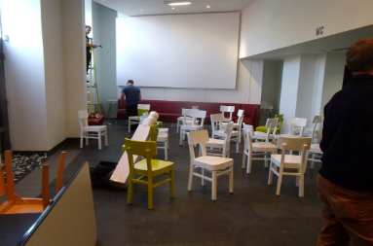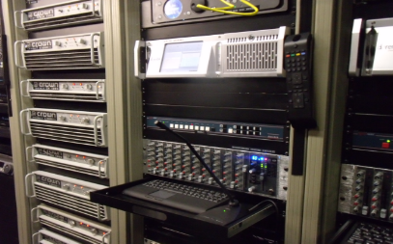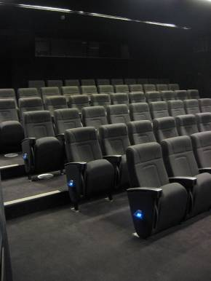
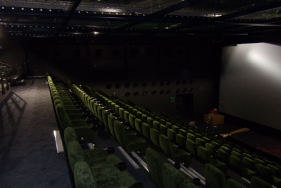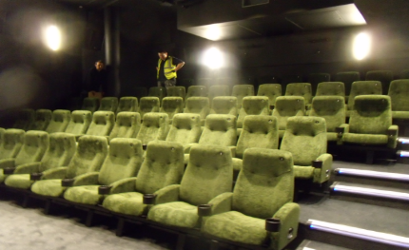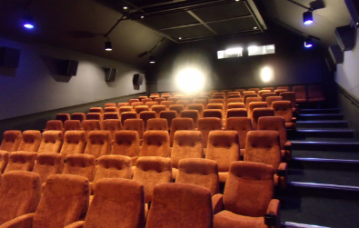

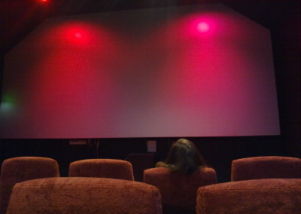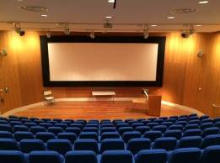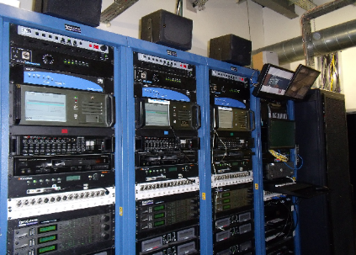
DERNGATE NORTHAMPTON

Fully automated D cinema
Projection and sound concept, design, integration, project management.
Technical consultancy and design
Alternative use integration
ARTS UNIVERSITY BOURNEMOUTH

D cinema, screen and education integration
Projection and sound concept, design, integration, project management.
Technical consultancy and design
Alternative use integration

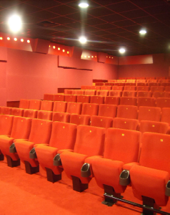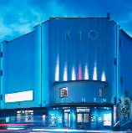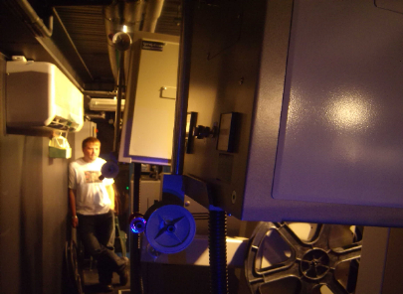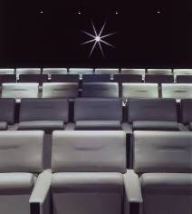

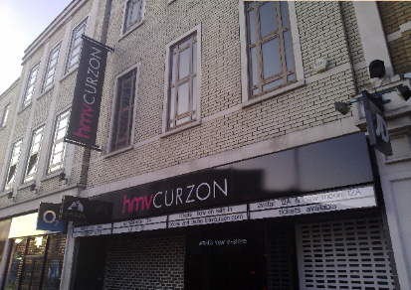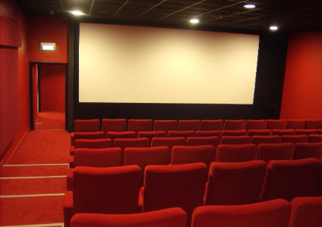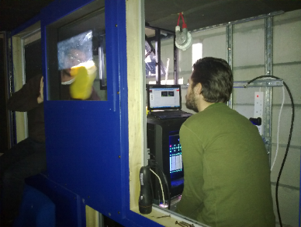
BIRKBECK COLLEGE
Technical design and consultancy
Projection and sound turnkey installation
35MM Film and E cinema

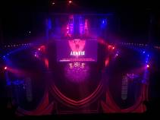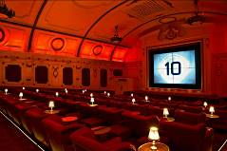

FORBURY HOTEL, READING
Technical design and consultancy
Projection and sound turnkey installation
35mm film, E cinema, satellite, conference
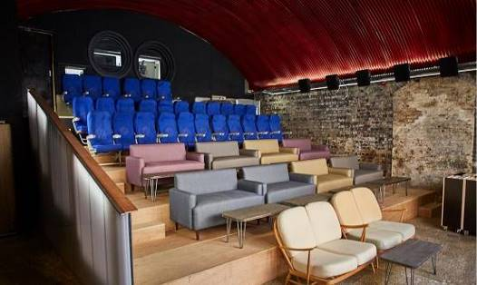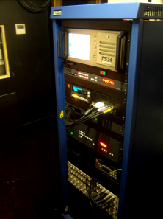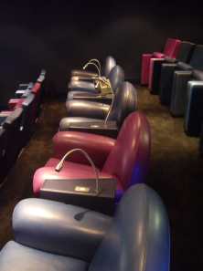

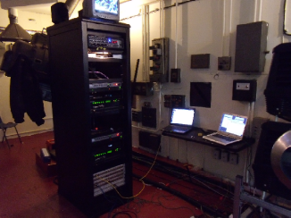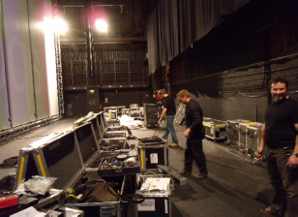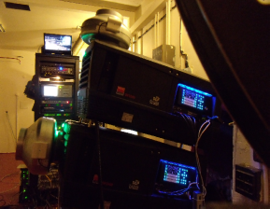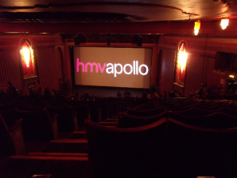
WORKING TITLE
Screening Room
Design
Technical design and consultancy -
Full CAD and Auditorium layout
Turkey Projection and sound
Digital Cinema and Film
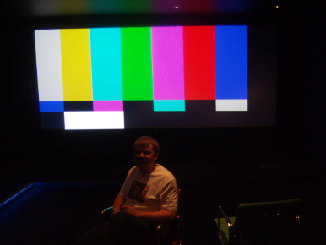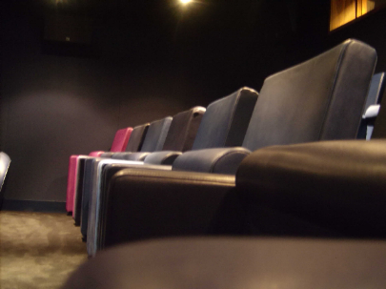

TERMS AND CONDITIONS OF SALE / TRADE

Definitions
“Buyer” means the person who buys or agrees to buy the Goods from the Seller
“Terms” means the terms of sale as set out in this document and any special terms as agreed in writing by the Seller.
“Delivery Date” means the date specified by the Seller when the equipment and Goods are to be delivered and installed.
“Goods” means any projector and other related equipment and any other goods and equipment which the Buyer agrees to buy from the seller.
“Price” means the Price for the Goods and Work excluding carrier packing, insurance and VAT.
“Seller” means Future Projections Limited (Company Registration Number 3797445) whose registered office is situated at Unit 2 Windsor Centre Windsor Court SE279NT.
“Work” means the supply and installation and the servicing and repair of the Goods by the Seller.

COMPLETION
Practical completion shall be deemed to be no later than the first public or commercial screening (or the ability to do the same) by the client and all sums due on completion shall be payable on this date. Should such payment not be received, Future Projections retain ownership of the equipment and any use will incur rental charges until all payments are received. The purchaser agrees to pay both the account due on completion and the rental charges - payments will be allocated to rental accounts before capital accounts.

Terms Applicable
These Terms shall apply to all contracts for the sale of Goods and Work by the Seller to the Buyer to the exclusion of all other terms including any terms or conditions which the Buyer may purport to apply under any purchase order confirmation of order or similar document.
All orders for Goods or Work shall be deemed to be an offer by the Buyer to purchase Goods pursuant to these Terms.
Acceptance of delivery of the Goods shall be deemed conclusive evidence of the Buyer’s acceptance of these Terms.
Any variation to these Terms (including any special terms and conditions agreed between the parties) shall be inapplicable unless agreed in writing by the Seller.

The Price and Payment
The Price shall be the Seller’s quoted price for the Goods and Work as varied by agreement. The Price is exclusive of VAT, which shall be due at the rate ruling on the date of the Seller’s invoice.
Payment of the Price and VAT and shall be due within 30 days of the date of the invoice. Time for payment shall be of the essence.
Interest on overdue invoices shall accrue from the date when payment becomes due from day to day until the date of payment at a rate of 4% above HSBC’s base rate from time to time in force and shall accrue at such a rate after as well as before any judgment.
Unless otherwise agreed in writing between the Buyer and the Seller, payment for the Work shall be made in accordance with the following terms: -
Regular monthly stage payments shall be paid by the Buyer to the Seller the first such payment being due on the last day of the month following that in which the Goods are despatched or the Work is due to commence as appropriate.
Each such stage payment shall comprise the total value of Work executed and materials and Goods delivered to site for use thereon by the Seller prior to the date of such stage payment together with any other amounts then due, less only the aggregate amount of any previous stage payments and any agreed retention but subject to no other deductions whatsoever.
In respect of any materials or Goods which through no fault of the Seller are held in store, the value of the same together with any charges in respect of storage or rehandling shall be included in each monthly stage payment.
If the Buyer fails to make any payment when due the Seller may, at its option, and without prejudice to any other rights under the contract, suspend further Works until such Payment is made or terminate the contract. The Seller shall be entitled to charge in full with all interest where applicable interest on the outstanding balance of all overdue accounts from the time of default to time of payment (as well after as before judgment) calculated on an annual basis at a rate of 4% above the base lending rate of HSBC.
Notwithstanding anything contained herein the Seller shall be under no liability for loss and profits, revenue, contracts or business or any other form of consequential or indirect loss or damage of any nature whatsoever and however caused or arising.

Goods and Work
The quantity and description of the Goods and/or Work shall be as set out in the Seller’s quotation.

Warranties And Liability
The Seller warrants that the Goods and/or Work will at the time of delivery correspond to the description given by the Seller and, except where the Buyer is dealing as a consumer (as defined in the Unfair Contract Terms Act 1977 Section 12), all other warranties, conditions or terms relating to fitness for purpose, merchantability or condition of the Goods and/or Work implied by statute or common law or otherwise are excluded, including any loss or damage caused by or arising the incorrect operation of the Goods concerned, misuse, neglect, fire, flood, explosion howsoever caused and act of God and all consequential loss howsoever caused.

Advanced replacement goods
Our warranty, and those of most of our suppliers is “return to base” – goods need to be returned to us for evaluation and repair. In the event of a failure, we may have available “advanced replacement items”, to serve as either an interim loan item or a replacement unit pending warranty evaluation by the manufacturer. When we send these items, we treat these as a purchase – the client purchases the advance replacement item off us, we invoice for this and all carriage and once we receive the faulty goods back and verify the warranty claim we credit the cost of the goods. Clients need to agree these terms in writing prior to advance replacements being sent.

Delivery Of The Goods
Delivery of the Goods shall be made to the Buyer’s address on the Delivery Date, which is an estimate only. The Buyer shall make all arrangements necessary to take delivery of the Goods at the agreed location with the appropriate room / space for the Goods whenever they are tendered for delivery
Time for delivery is not of the essence of the contract
The Seller shall not be liable for any loss or damage whatever due to failure by the Seller to deliver the Goods (or any of them) promptly or at all.

Acceptance of the Goods and work
The Buyer shall be deemed to have accepted the Goods and/or Work 7 days after the date of the invoice relating to such Goods.
After acceptance the Buyer shall not be entitled to reject Goods and/or Work, which are not in accordance with the contract.

Title and Risk
The Goods shall be at the Buyer’s risk as from delivery.
In spite of delivery having been made title in the Goods shall not pass from the Seller until the Buyer shall have paid the Price plus VAT in full for such Goods.
Until title in the Goods passes to the Buyer in accordance with clause 8.2 the Buyer shall hold the Goods and each of them on a fiduciary basis as bailee for the Seller.
The Seller shall be entitled to recover the Price (plus VAT) notwithstanding that title in any of the Goods has not passed from the Seller.
Until such time as title in the Goods passes from the Seller the Buyer shall upon request deliver up the Goods. If the Buyer fails to do so the Seller may enter upon any premises owned occupied or controlled by the Buyer where the Goods are situation and repossess the Goods. On the making of such request the rights of the Buyer under clause 8.4 shall cease.
The Buyer shall not pledge or in any way charge by way of security for any indebtedness any of the Goods which are the property of the Seller. Without prejudice to the other rights of the Seller, if the Buyer does so all sums whatever owing by the Buyer to the Seller shall forthwith become due and payable.
The Buyer shall insure and keep insured the Goods to the full Price against “all risks” to the reasonable satisfaction of the Seller from the date of delivery until the date that property in the Goods passes from the Seller, and shall whenever requested by the Seller produce a copy of the policy of insurance. Without prejudice to the other rights of the Seller, if the Buyer fails to do so all sums whatever owing by the Buyer to the Seller shall forthwith become due and payable.
If requested by the Seller, the Buyer shall promptly deliver the prescribed particulars of this contract to the Registrar in accordance with the Companies Act 1985 Part XII as amended. Without prejudice to the other rights of the Seller, if the Buyer fails to do so all sums whatever owing by the Buyer to the Seller shall forthwith become due and payable.

Remedies of Buyer
Where the Buyer rejects any Goods and/or Work then the Buyer shall have no further rights whatever in respect of the supply to the Buyer of such Goods and/or Work or the failure by the Seller to supply Goods and/or Work which conform to the contract of sale.
Where the Buyer accepts or has been deemed to have accepted any Goods and/or Work then the Seller shall have no liability whatever to the Buyer in respect of those Goods.
The Seller shall not be liable to the Buyer for late delivery or short delivery of the Goods.
The Buyer shall inspect the Goods and/or Work on delivery and after installation and shall within 3 days after delivery or after installation notify the Seller of any alleged defect, shortage of quantity, damage or failure to comply with description or sample. If the Buyer shall fail to comply with these provisions the Goods and/or Work shall be conclusively presumed to be in accordance with the contract and free from any defect or damage which would be apparent on a reasonable examination of the Goods and/or Work, the Buyer shall be deemed to have accepted the Goods and/or Work.
If the Goods and/or Work are not in accordance with the contract for any reason the Buyer’s sole remedy shall be limited to the Seller making good any shortage by replacing such Goods and/or Work or, if the Seller shall elect, by refunding a proportionate part of the Price.
The Seller’s liability to the Buyer, whether for any breach of contract or otherwise, shall not in any event exceed the Price and the Seller shall be under no liability for any direct loss and/or expense or indirect loss and/or expense suffered by the Buyer or liability to third parties incurred by the Buyer.

GOVERNING LAW
This contract is subject to the Law of England and Wales.
The Seller warrants all Work carried out and covered by this estimate for a period of 6 months in respect of labour and workmanship. The Seller shall repair or replace defective Goods at his discretion. Any parts or Goods supplied and fitted by the Seller shall carry the warranty (if any) given by the manufacturer of that item. The Buyer shall during the relevant period ensure that the equipment is operated and maintained correctly

Cabling and other items
The Seller shall where reasonably possible conceal electrical cable within containment provided by othersm or otherwise as agreed. Price does not include the lifting and replacement of floorboards for the purpose of concealing cable.
Cables affixed to walls ceilings and doors shall be affixed to the surface thereof and the quotation or estimate or Price does not include the costs of concealing such cable.
The Buyer shall give the Seller access to its premises of not less than 8.5 clear hours per day between the hours of 7.00 am and 5.00 pm Monday to Saturday for the purpose of carrying out any act and the services and Work under the terms of this agreement.
The Buyer shall provide without charge to the Seller adequate facilities for the storage of materials equipment and tools during the carrying out of the Work and for a reasonable time before commencement and after completion.
Materials equipment and tools stored at the Buyers premises or premises under his control shall be stored at the sole risk of the Buyer. In the event of destruction damage or theft of materials equipment and tools stored at the Buyers premises or premises under his control the Seller shall be entitled to payment in full in respect thereof except that the Buyer shall not be liable or any loss occasioned solely by the negligence of the employees or agents of the Seller.
The Work will be performed during the Seller’s normal working hours.
The Work shall be executed within the period of time stated in the quotation or in accordance with a programme of work to be agreed in writing with the proviso that the date stated in the quotation or such programme shall be subject to confirmation after all the specifications and measurements have been taken and agreed. The Seller shall be afforded proper access to site to enable specification and measurements to be taken. Any alteration or deviation from programme shall thereafter only be made by mutual agreement.
A fair and reasonable extension of time to the period stated in the quotation or to the agreed programme shall be made by the Buyer in the event of the Seller suffering delays caused by war riot civil commotion force measure acts of god inclement weather strikes lockouts or any other form of industrial action shortages of labour or materials delay in delivery of materials by suppliers or sub-contractors or any other unforeseen circumstances beyond the Seller’s reasonable control.
The Buyer must give the minimum period of notice stated in the quotation in writing before the Seller is obliged to commence work on site. The Buyer shall provide free and adequate access to the site at all times. Hard standings and approach roads suitable for the Seller’s vehicles shall be available to allow for the safe handling of materials and a suitable area for storage of materials. Any hutting, which may be required, shall be made available within close proximity to the place at which the work is to be carried out.
The Buyer shall provide on site, at no charge to the Seller, all equipment and facilities required to enable the Seller to fulfil the requirements of the Buildings (Safety, Health and Welfare) Regulations, the Factories Act and all other applicable legal requirements.
The Seller’s insurances in respect of public liability and third party liability indemnify the Buyer or his or her agent against any claims arising from damage to the premises at which the Seller is working and/or injury to any person or persons within or adjacent to those premises provided that such injury is due to proved negligence on the part of the Seller or on the part of its employees. Save as provided in this paragraph the Seller has no obligations to indemnify the Buyer or to insure.
The Buyer will be responsible for insuring in the joint names of the Buyer and the Seller against loss and damage by fire, lightning, explosion, storm, tempest, flooding bursting or overflowing of water tanks, apparatus and pipes, earthquake, aircraft and other aerial devices or articles dropped there from, riot and civil commotions all Work executed and all uninstalled materials and Goods delivered to or placed on or adjacent to the site or the Buyer’s premises and shall maintain such insurance until practical completion of the Work.
In the event of such loss or damage, the Seller will reinstate or make good such loss or damage and carry out and complete the Work. The reinstatement and making good of such loss or damage shall be deemed to be variation under paragraph 16.6 below. If it is just and equitable the Seller may determine its engagement under the contract within 28 days of the occurrence of such loss or damage.
The Buyer will be entitled to vary the design, quality and quantity of the Work subject to agreeing acceptable adjustment with the Seller to the price payable and the period for completion of the Work and any other terms of the contract of which these Conditions form part which the Seller may consider relevant. The Buyer will be responsible for the removal of all rubbish arising from the execution of the Work at no cost to the Seller.

RoHS Compliance Statement
The RoHS directive restricts the use of certain hazardous substances commonly used in the manufacturing of electronic equipment and requires producers of electronic equipment to reduce the concentration of these hazardous materials which include:

• Lead
• Mercury
• Cadmium
• Hexavalent Chromium
• Polybrominated Biphenyls (PBB)
• Polybrominated Diphenyl Ethers (PBDE)

The RoHS directive states that as of July 1, 2006, electrical and electronic equipment manufacturers must eliminate the use of all of the above materials. Although RoHS is a European Union (EU) Directive, manufacturers of EEE outside Europe must also abide by this legislation if the equipment they produce is ultimately imported into an EU member state. . In our role as an integrator, installer and service provider, we ensure that all products, cables, parts and supplies sourced are compliant and the ROHS certification provided or available.
You can be assured that we here, at Future Projections Ltd are concerned with a smooth transition to insure a continuous flow of product and to continue to maintain a high level of service to our customers.

WEEE Compliance Statement
The European Union also adopted Directive 2002/96/EC on Waste Electrical and Electronic Equipment (WEEE), with requirements that went into effect August 13, 2005. WEEE is intended to reduce the disposal of waste from electrical and electronic equipment by establishing guidelines for prevention, reuse, recycling and recovery.
Future Projections Ltd has addressed its practices and processes to conform to the requirements in this important Directive.
As a distributor of electrical and electronic devices, we accept our joint responsibility to ensure safe and appropriate disposal and recycling of electronic based equipment at the end of it’s lifespan as required and defined under WEEE regulations. Where equipment has been supplied and installed by ourselves, our installations are considered for the purposed of WEEE regulations to be fixed installations or in some cases large scale industrial tools and therefore outside the scope of the regulations. Where items are considered applicable to WEEE regulations, we ensure that the manufacturer or UK importer maintains a “take back” facility and that all products are marked with the crossed “wheeled bin” symbol. Whist there are no obligations for distributors in relation to sales of nonhousehold EEE, or for the take-back of non-household WEEE, as part of the supply chain for non-household EEE, we endeavour to assist producers and non-household end-users in discharging their obligations under the WEEE Regulations.

All sales are recorded and records retained for a minimum of four years.

WEEE regulations apply only to new sales. We operate an “in house” scheme for the return of WEEE applicable items to manufacturers and suppliers. As an alternative we often recycle such goods in-house for support and spare part functions of similar equipment in the field. We prioritise reuse of appliances as whole appliances, in either their original form or as spare parts of modified assembly.

